**Pharmanet Network**

1. Copy the package or extract the zip file to the workspace folder.
2. Go to the terminal and to the network directory of the pharma-network.
3. Type the command **./fabricNetwork.sh up** for the network to be up and running.  
   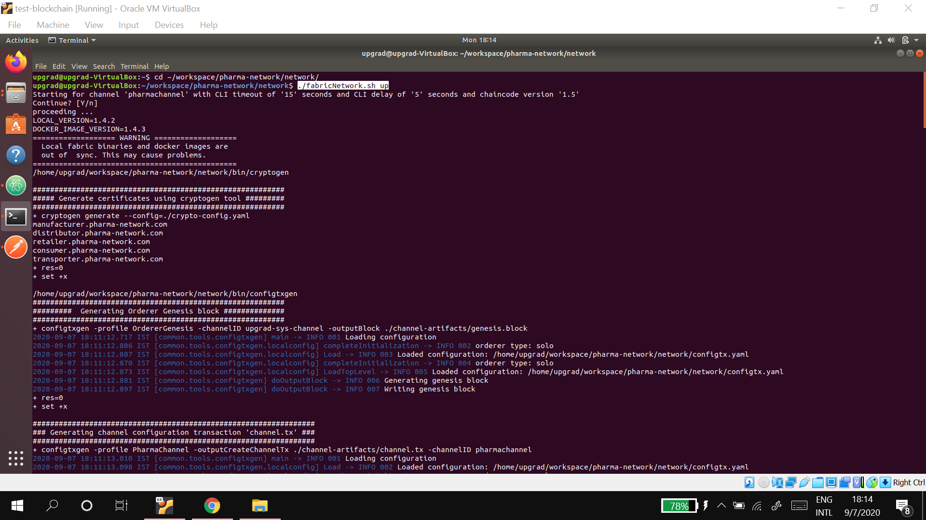
4. Open another terminal to the same directory, cli into the chaincode and type the command **npm install**, this will install all the necessary packages.  
   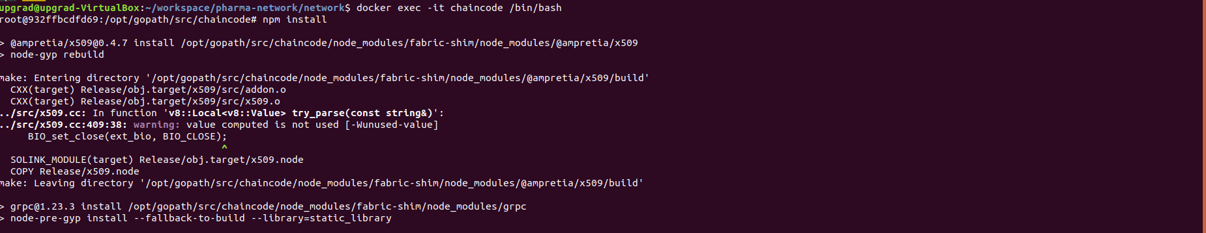
5. Next type the command **npm run start-dev** this will run the chaincode.  
   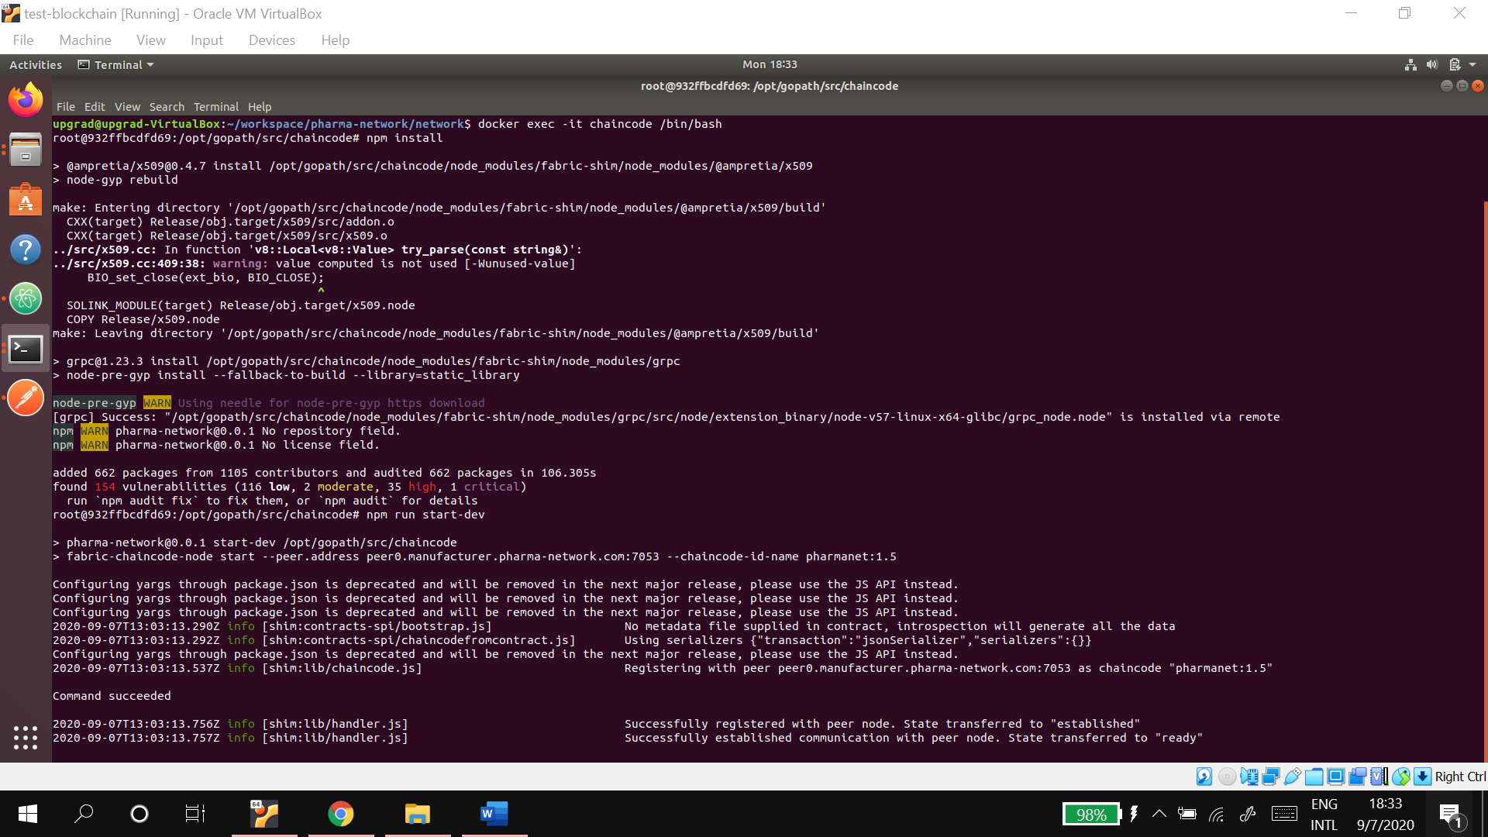
6. Next we need to install and instantiate the network, for which use the command **./fabricNetwork install**.  
   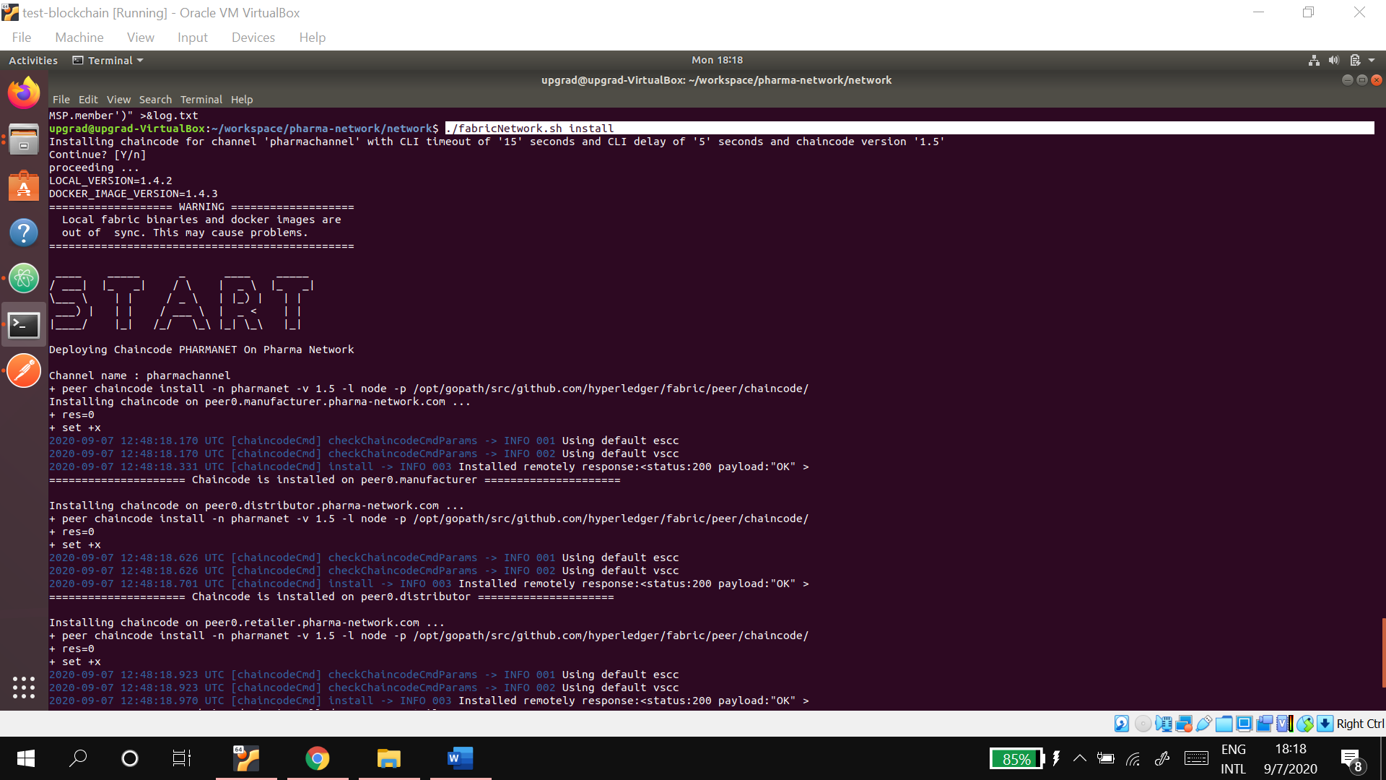
7. After the network has been installed and instantiated, got to another terminal and to the application directory of the pharma-network.
8. Update the private key in the file 1_addToWallet.js.  
   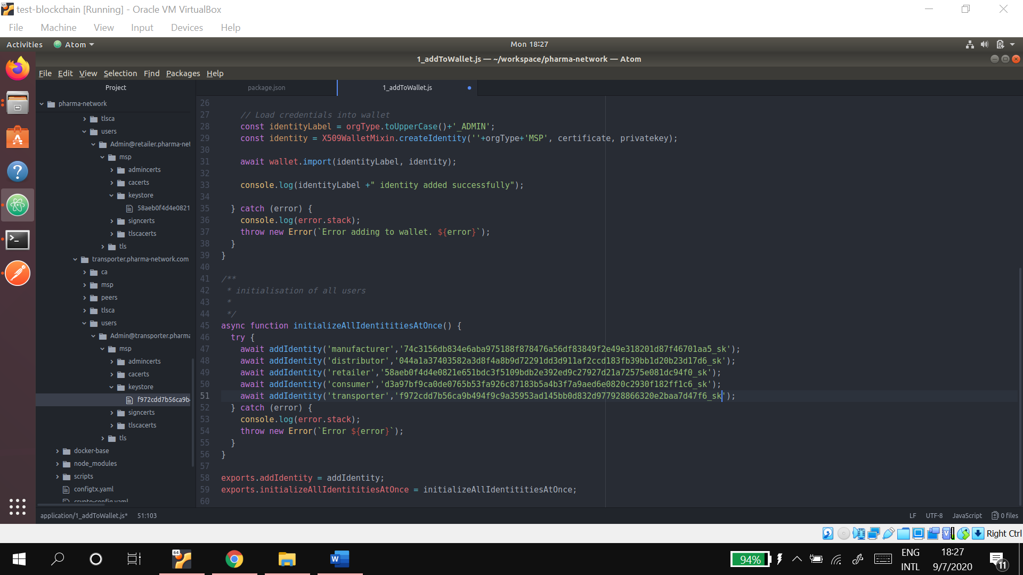
9. Install the required node modules using **npm install**  
   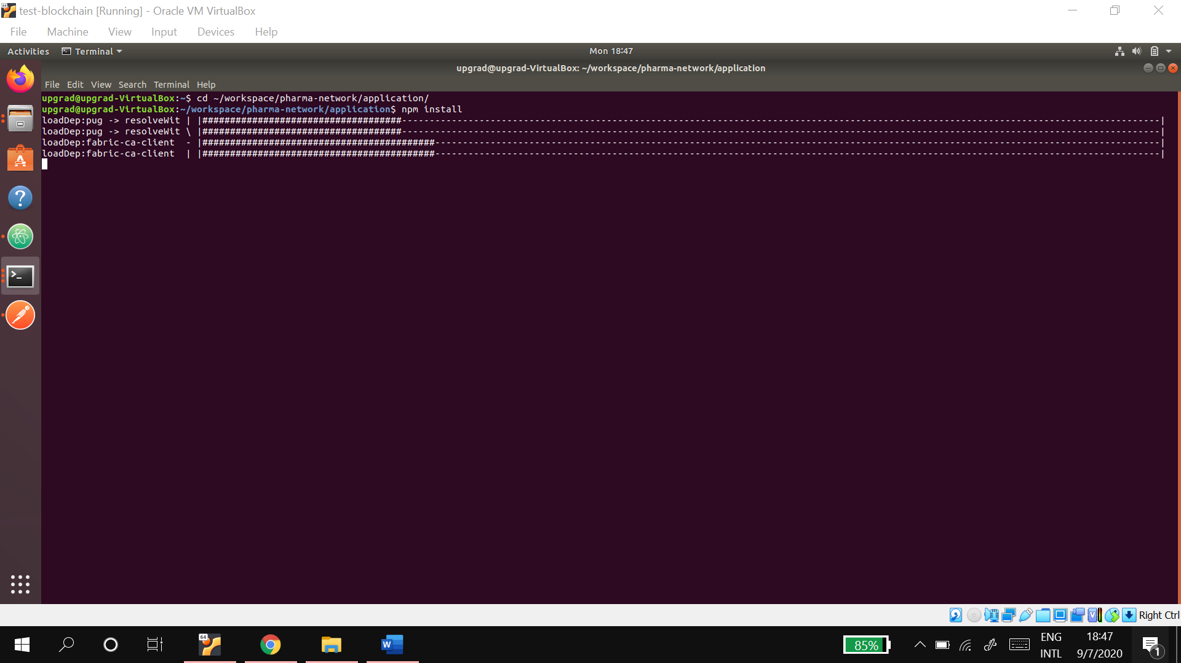
10. Here type the command **node index.js** which will run the application and host the node server created on the port 3000.  
    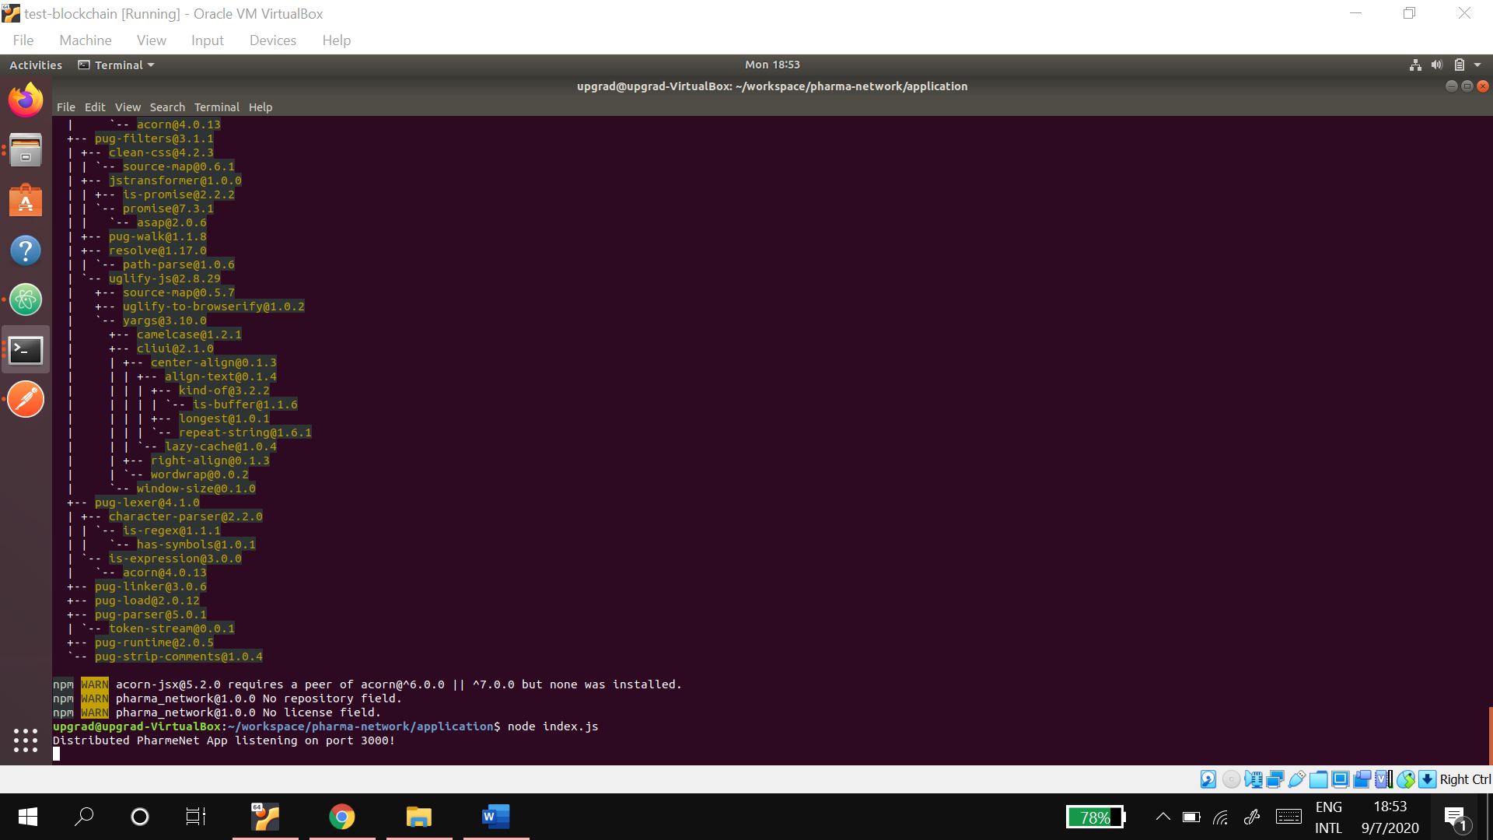
11. Now go to postman and then test the apis created, collections are attached in the folder.
12. Check if the network has been setup properly.  
    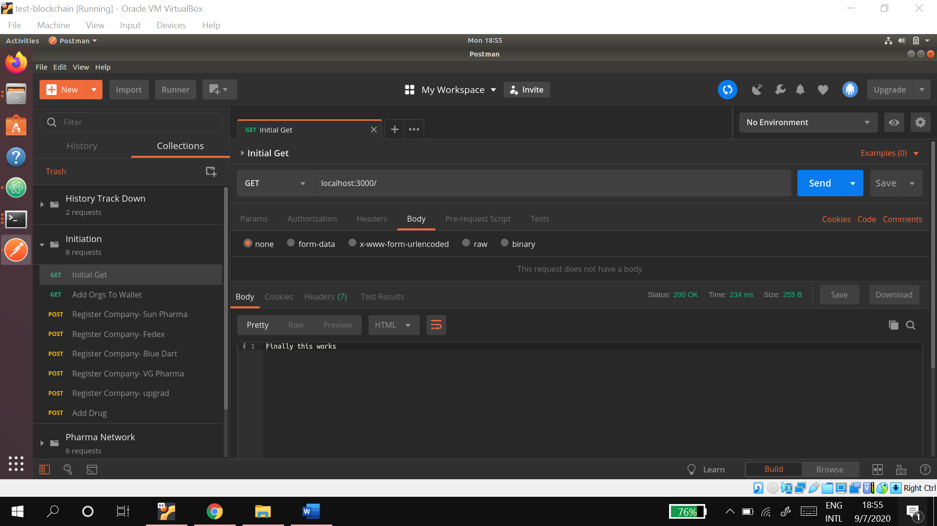
13. Add the organizations to the wallet  
    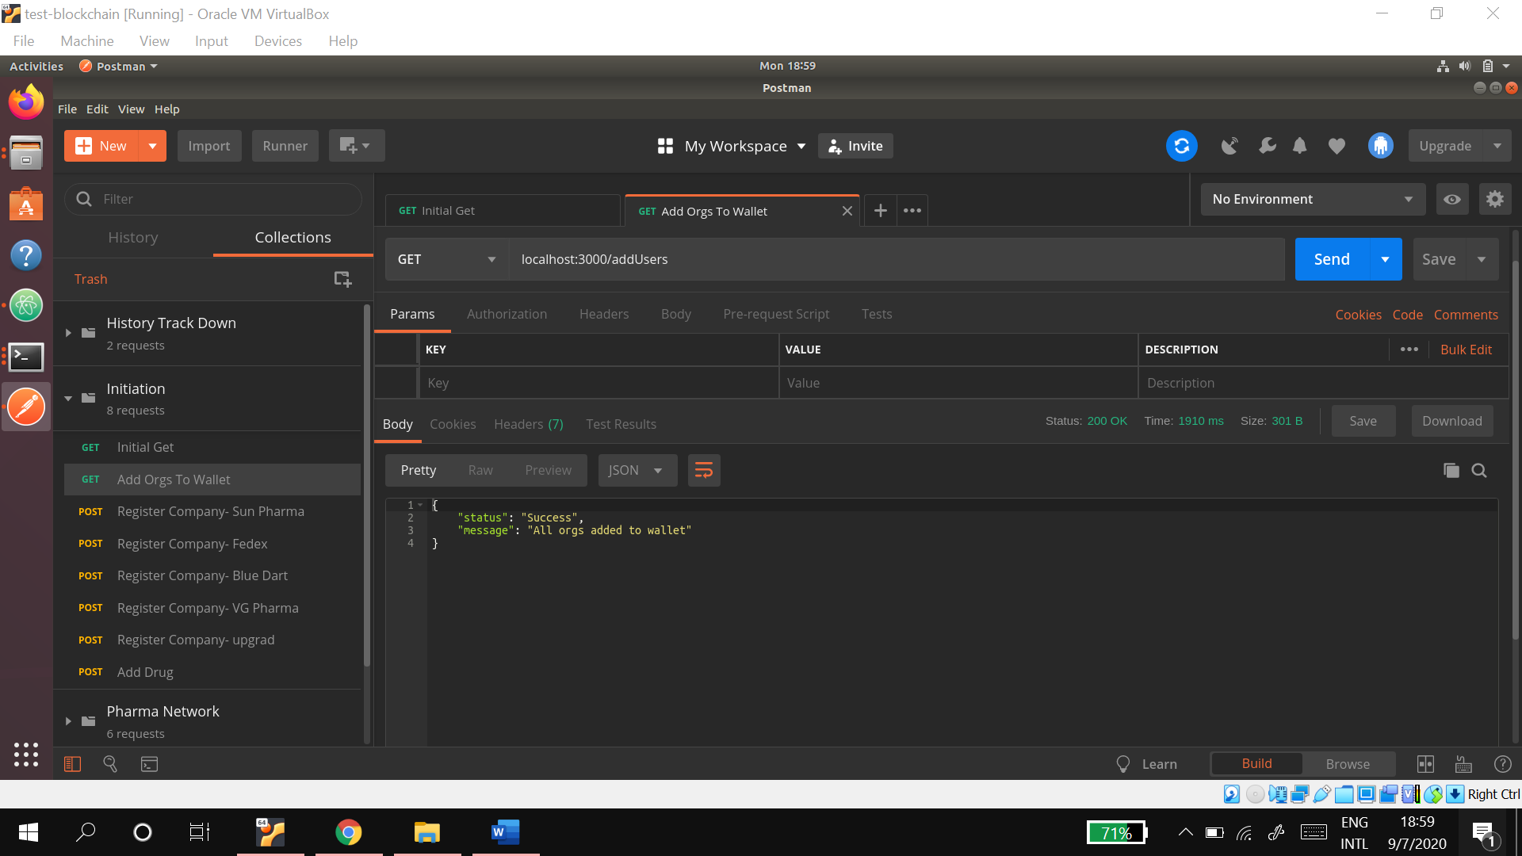
14. Testing Instantiate- Create a manufacturer - Sun Pharma  
    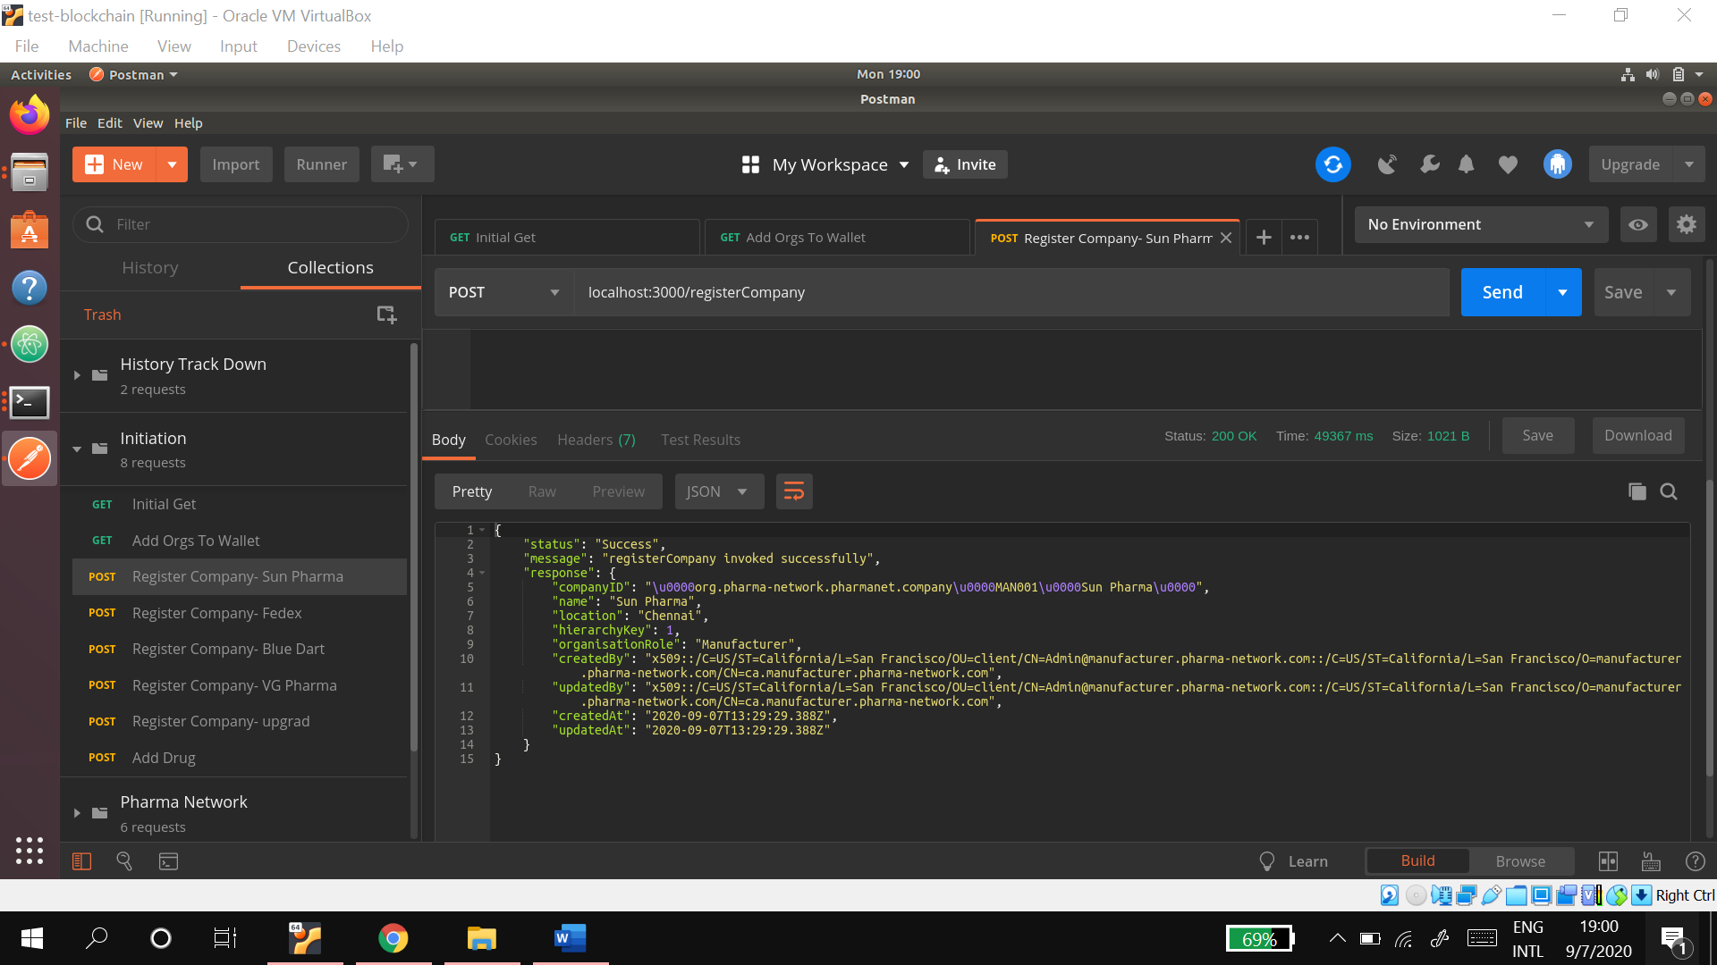
15. Create a transporter – FedEx  
    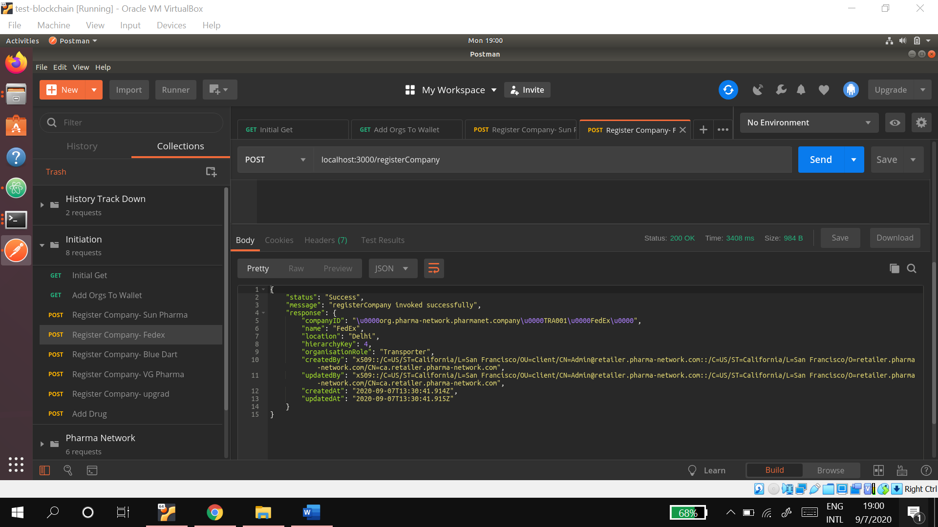
16. Create another transporter-Blue Dart  
    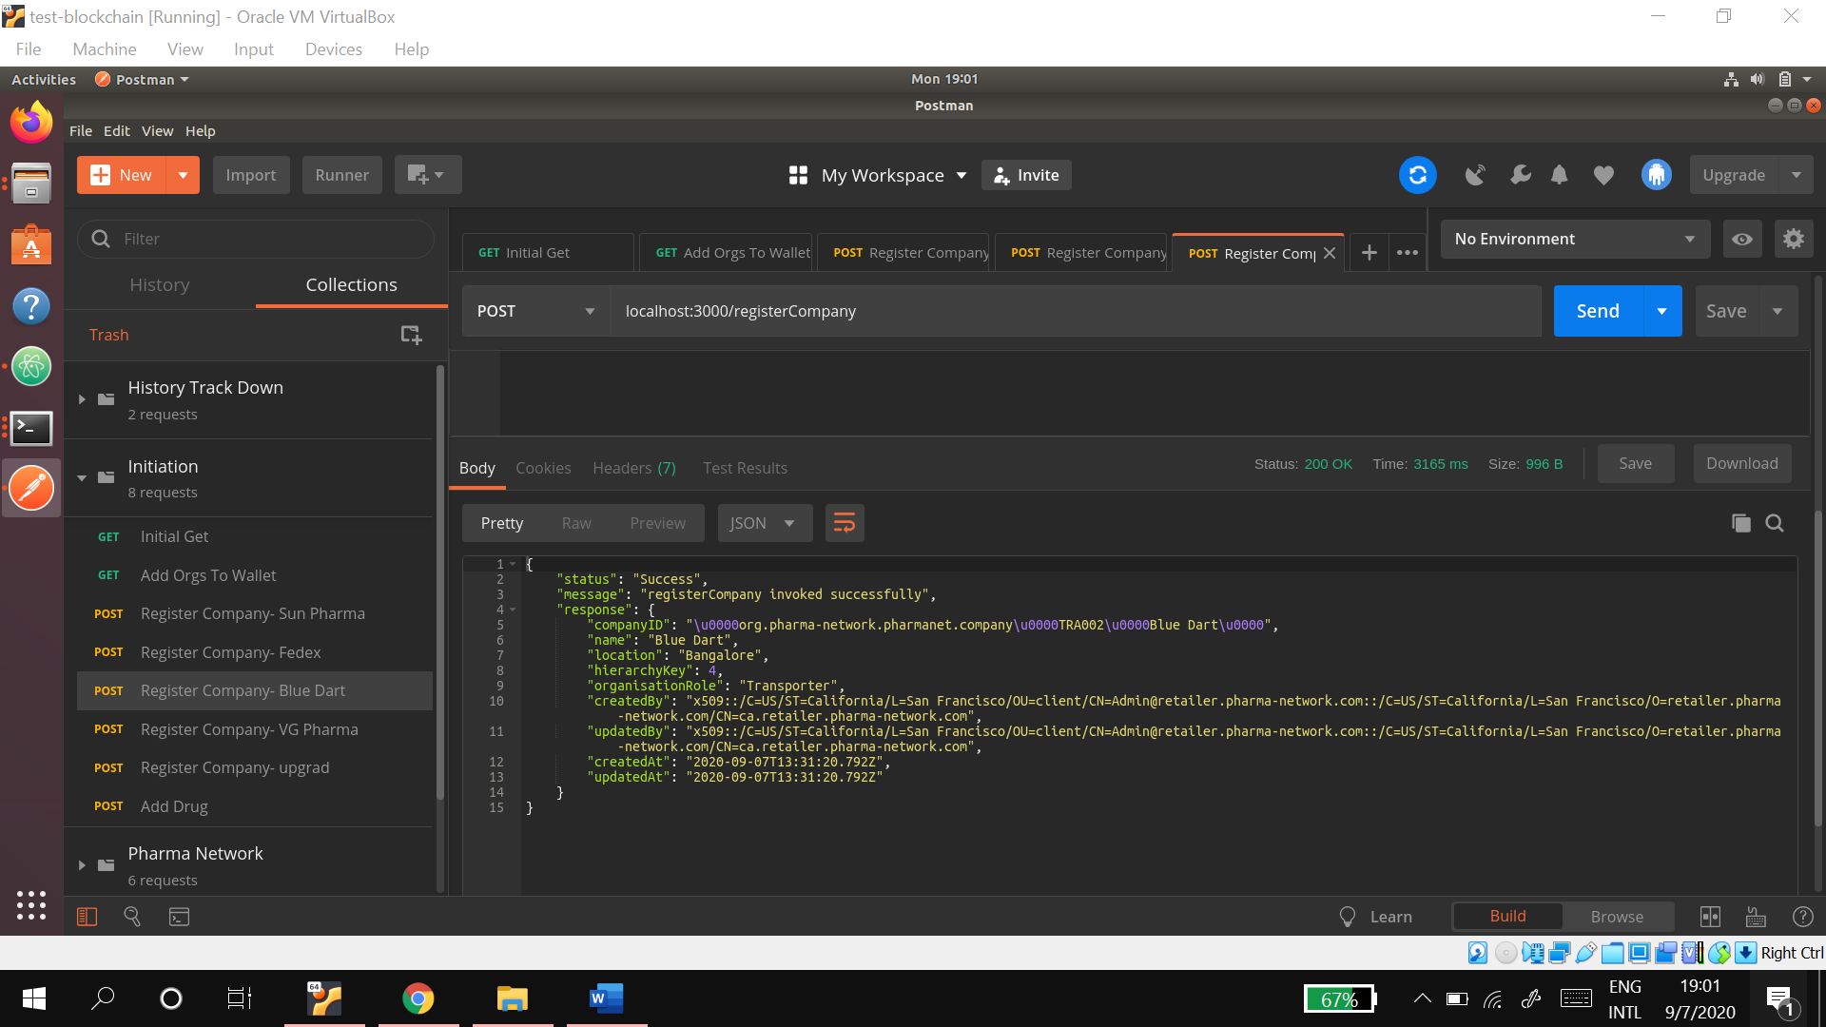
17. Create a distributor - VG Pharma  
    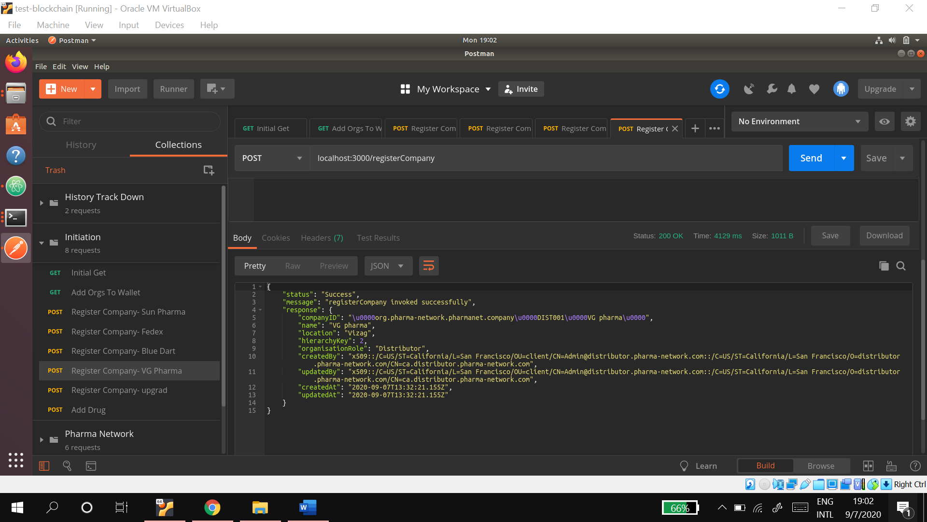
18. Create a retailer – upgrad  
    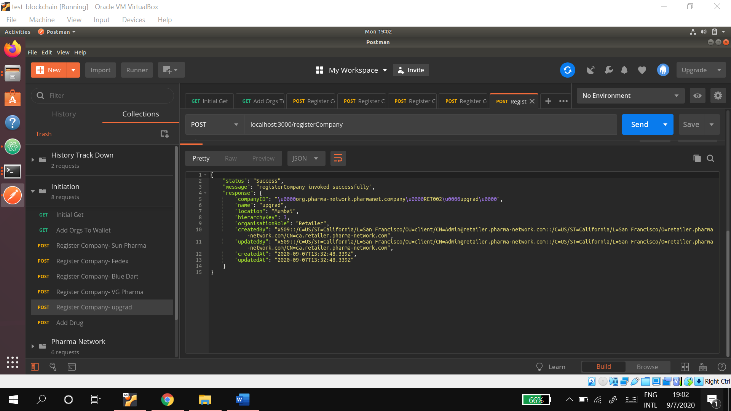
19. Create 4 strips of a drug  named ‘Paracetamol’  
    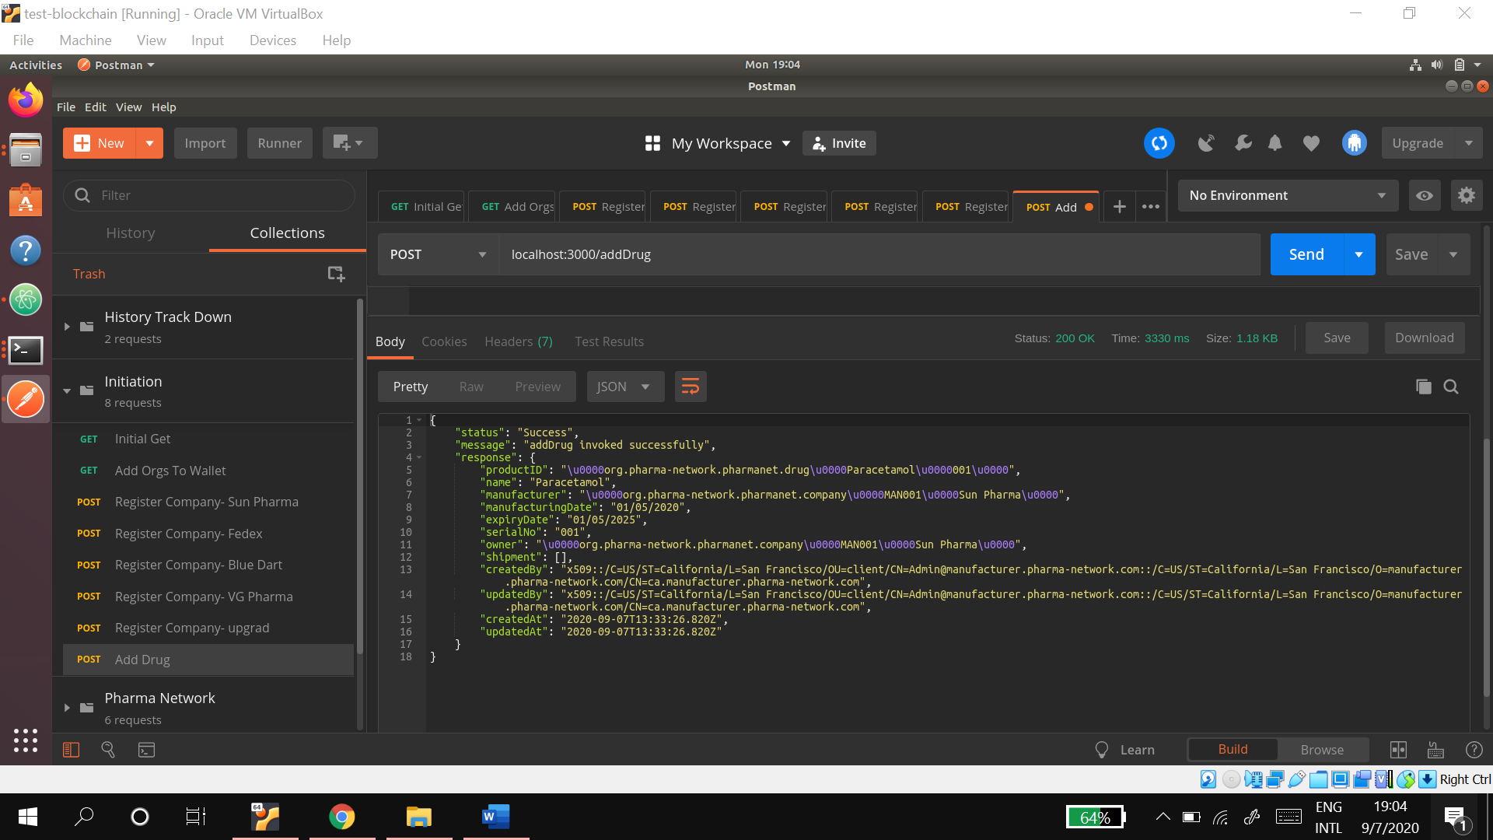  
    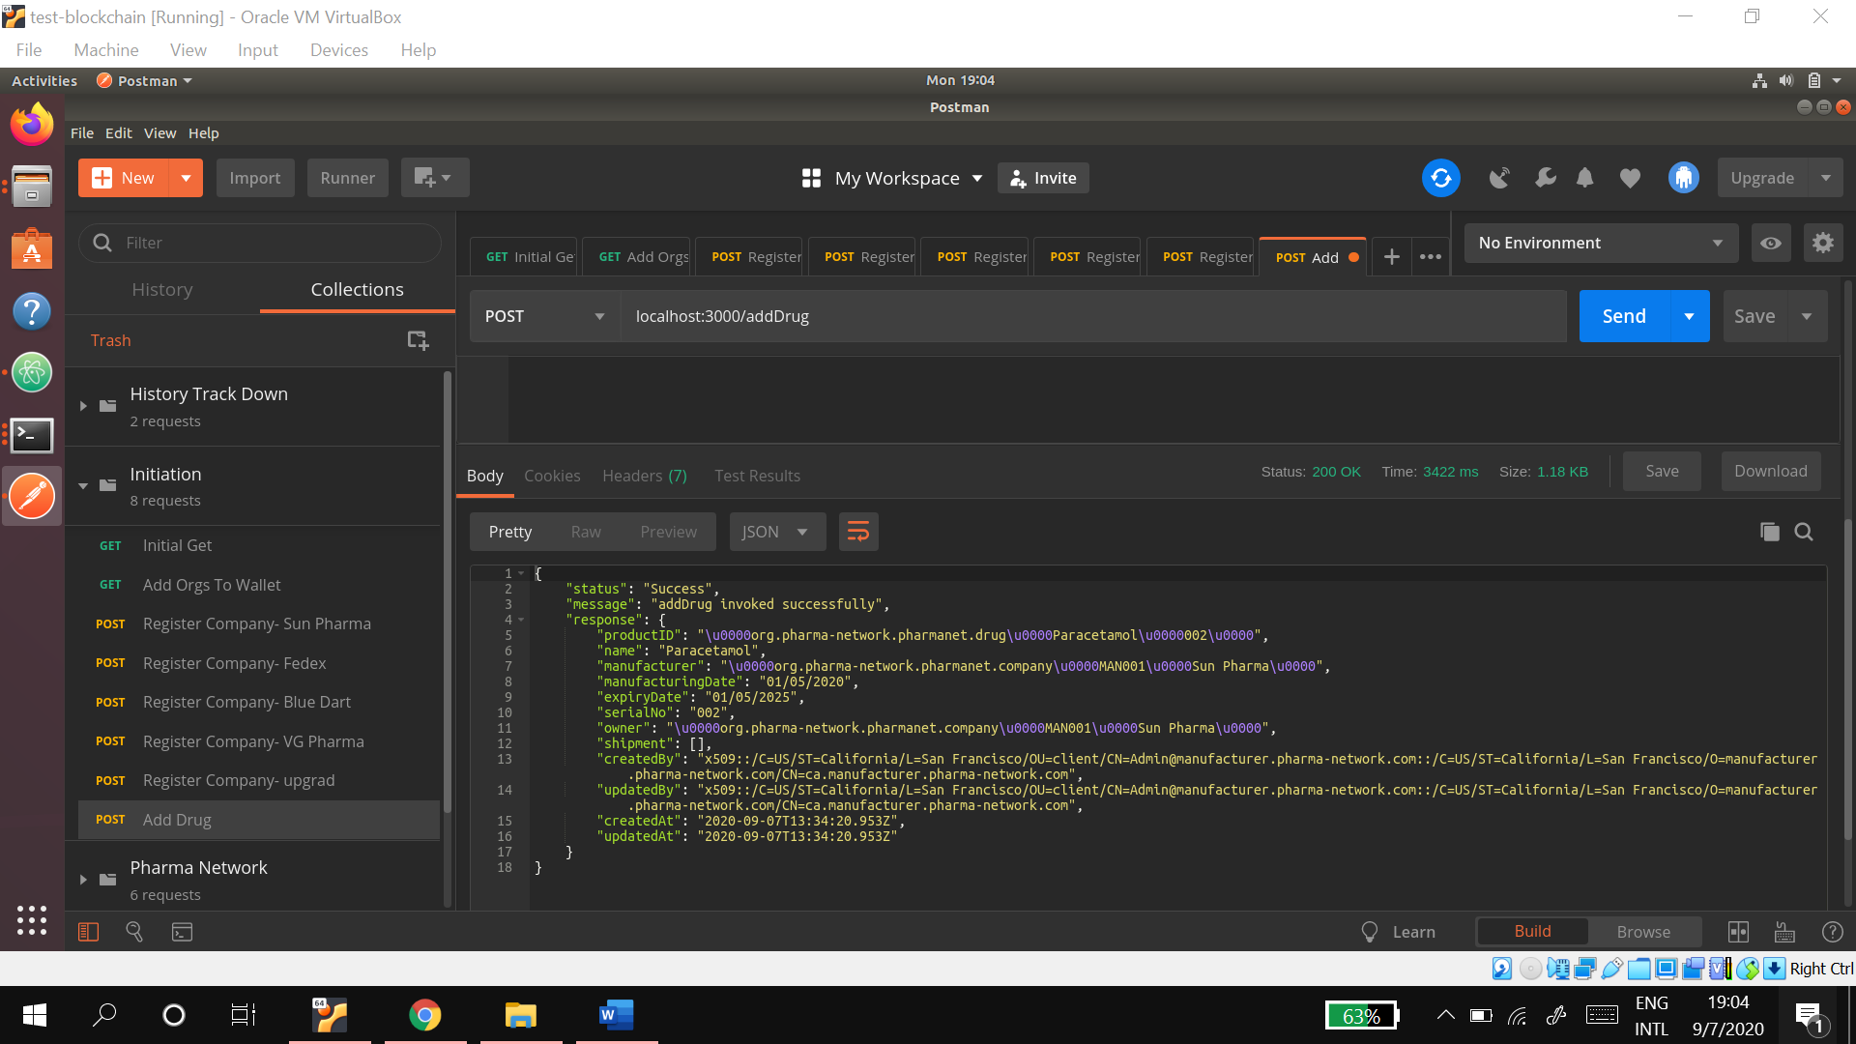  
    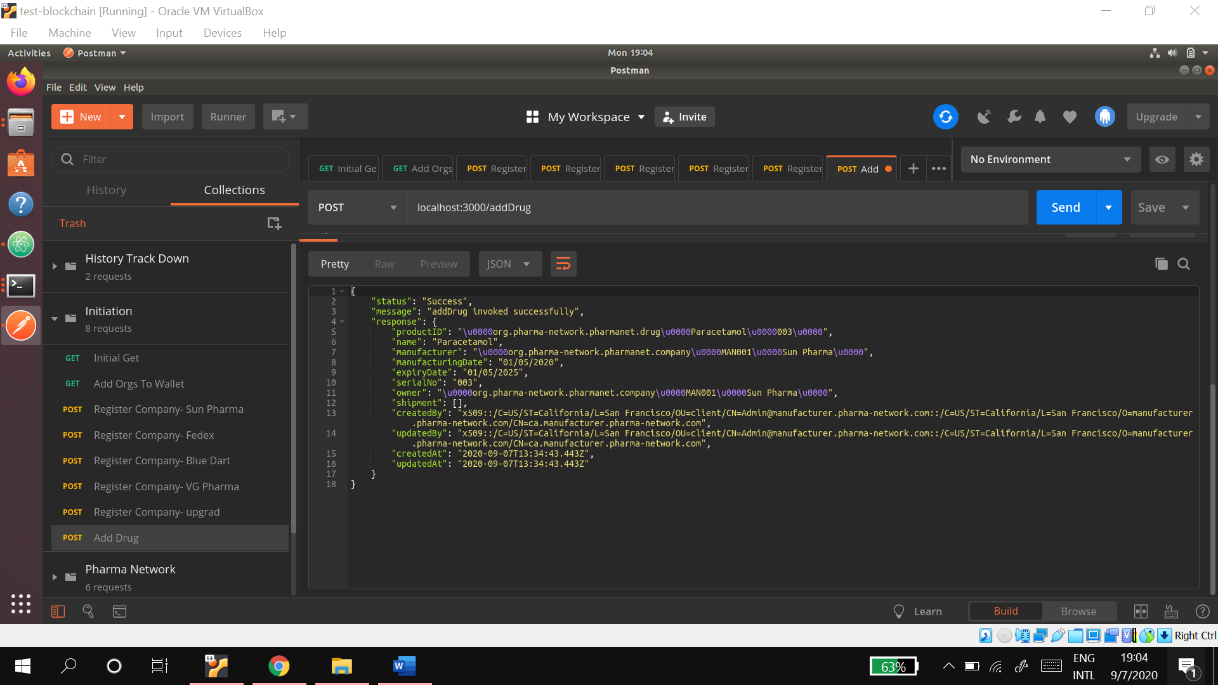  
    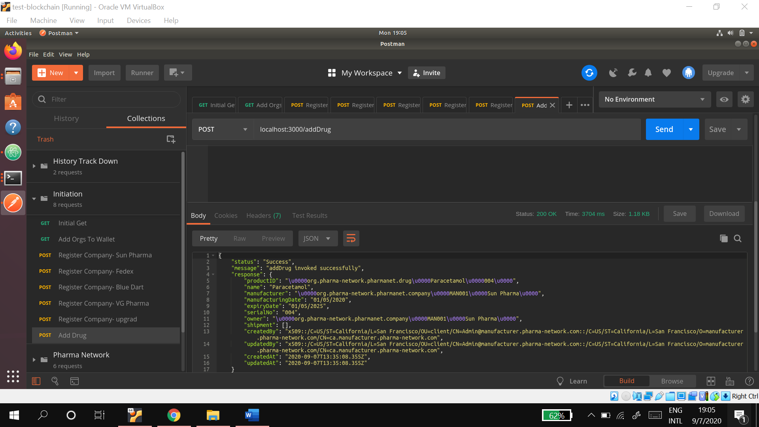
20. **Testing Supply Chain – Part A** Purchase Order raised by ‘VG Pharma’ to purchase 3 strips of paracetamol from ‘Sun Pharma’.  
    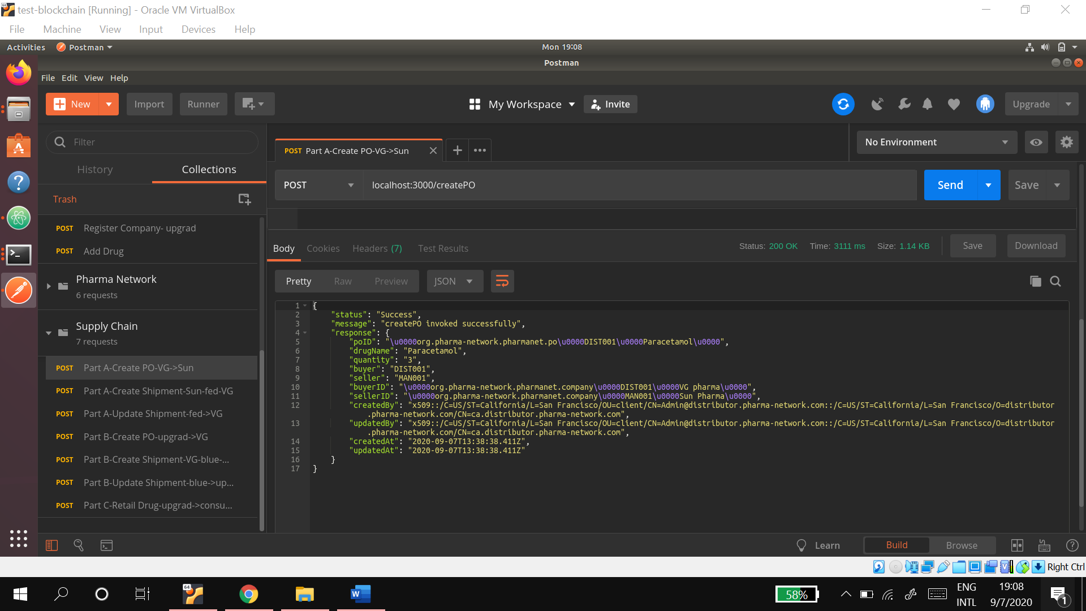
21. Shipment created by ‘Sun Pharma’ in response to the raised purchase order. ‘FedEx’ acts as the transporter  
    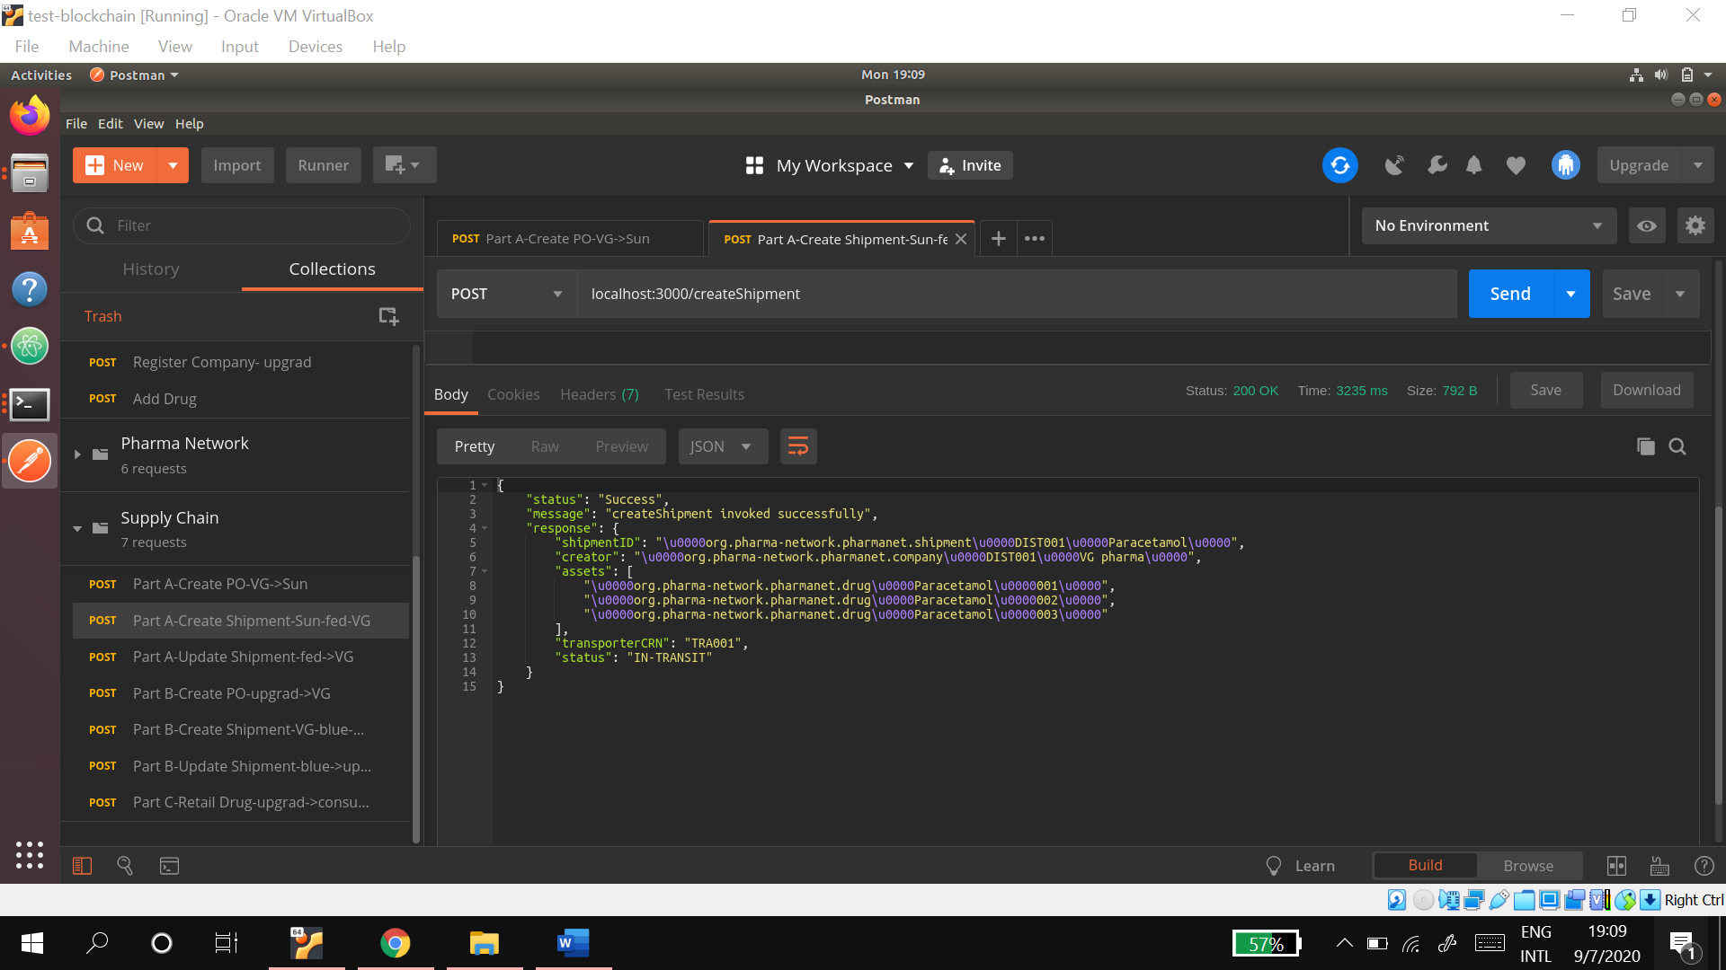
22. ‘FedEx’ delivers the shipment to ‘VG pharma’.  
    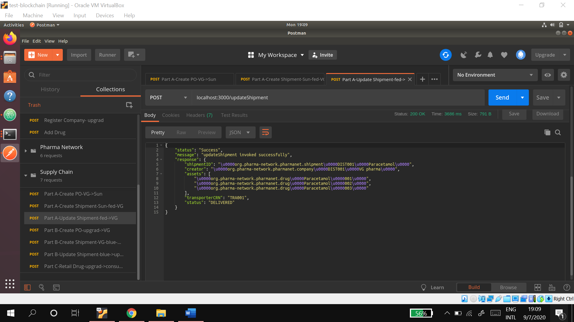
23. **Part B -** Purchase Order raised by ‘upgrad’ to purchase 2 strips of paracetamol from ‘VG Pharma’.  
    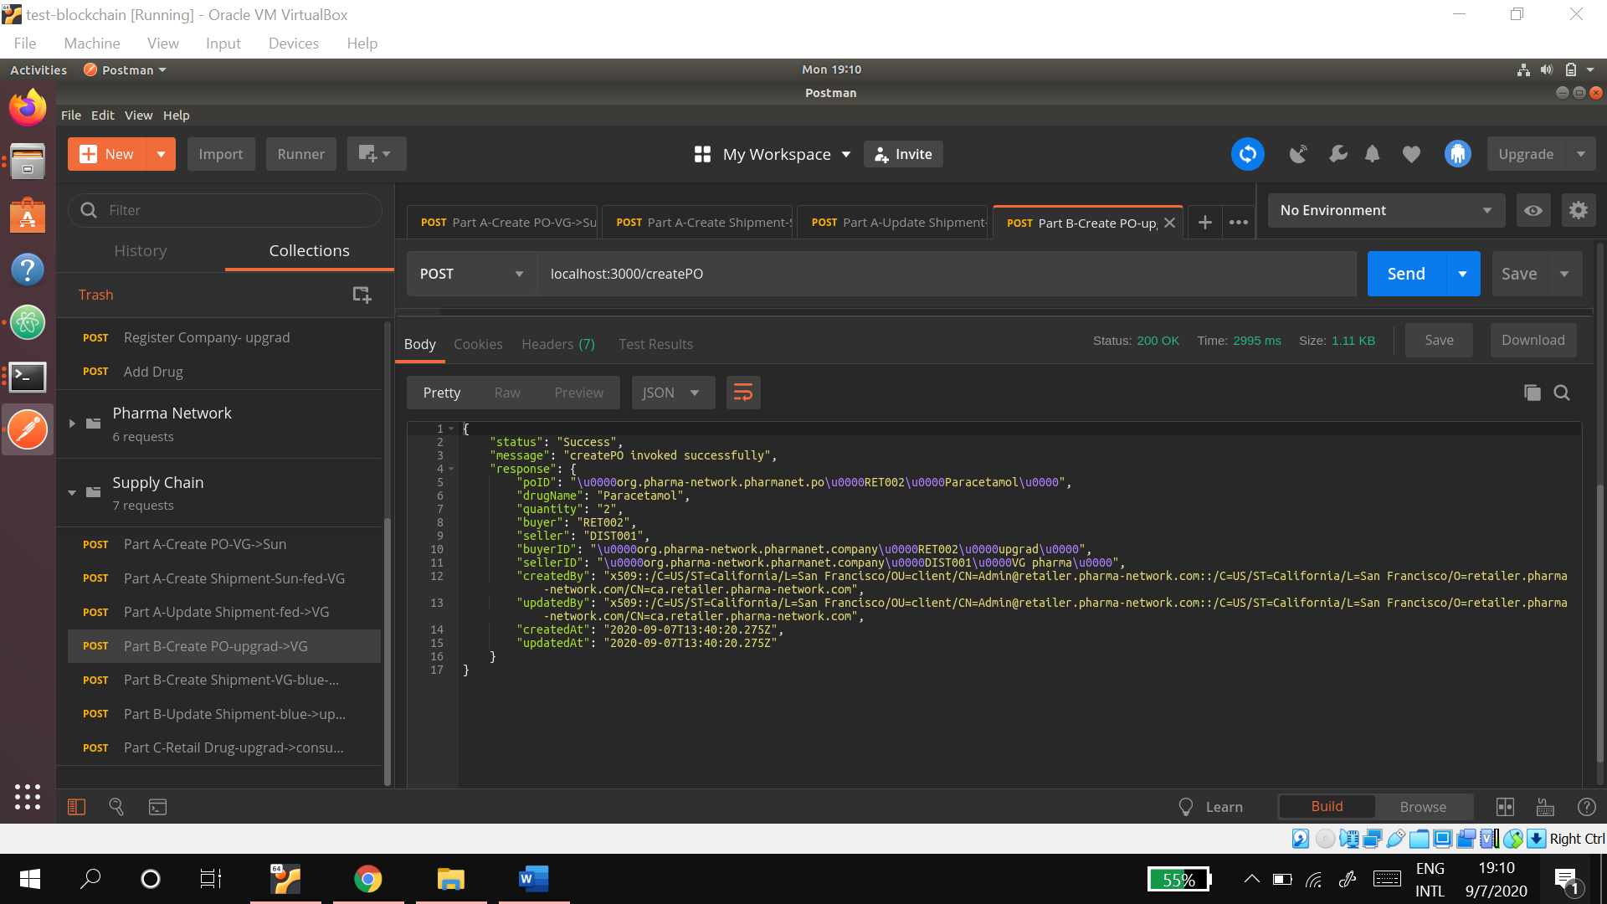
24. Shipment created by ‘VG Pharma’ in response to the raised purchase order. ‘Blue Dart’ acts as the transporter.  
    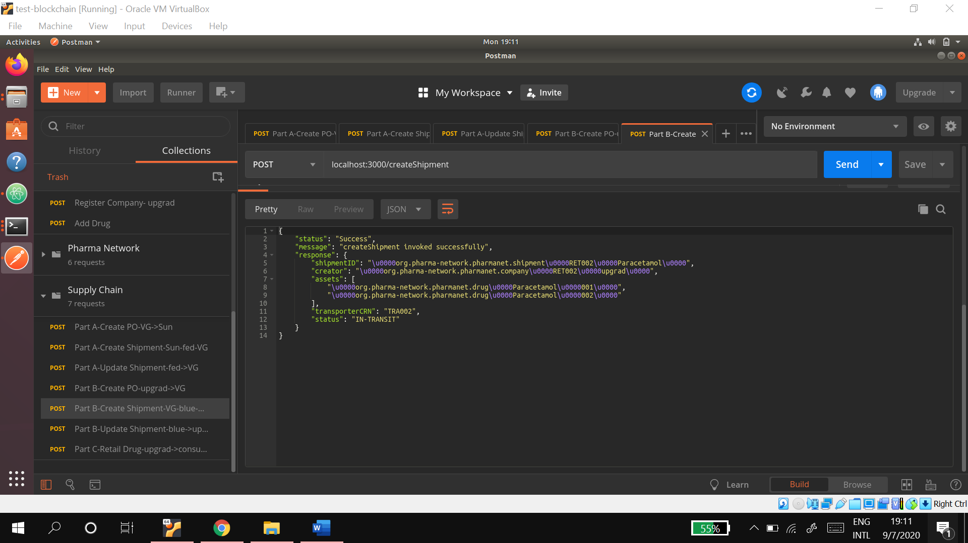
25. ‘Blue Dart’ delivers the shipment to ‘upgrad’.  
    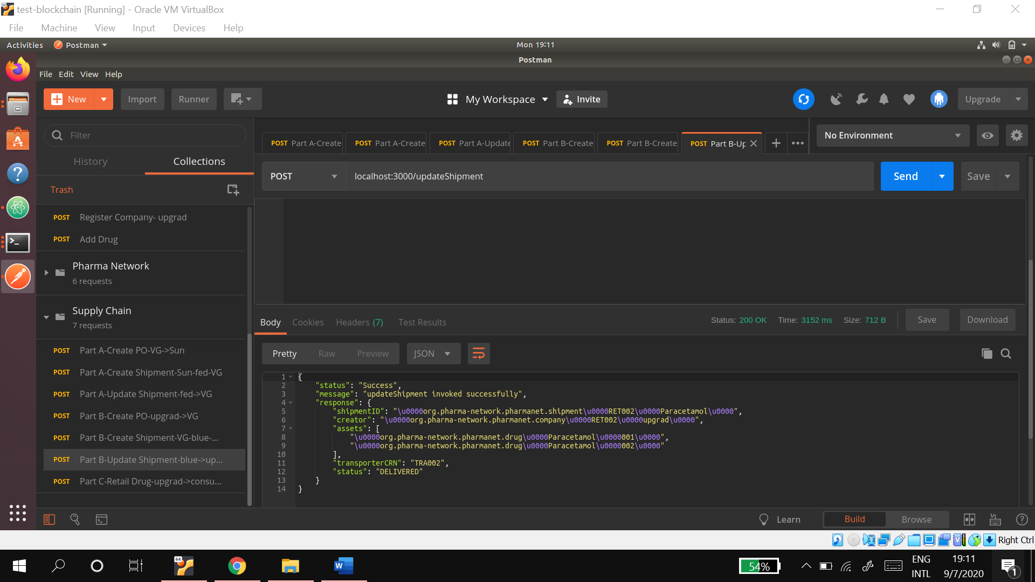
26. **Part C** - A customer named ‘Akash’ with Aadhar Number 'AAD001'  buys 1 paracetamol strip from the retailer ‘upgrad’.
27. **Testing History Track Down -** The customer ‘Akash’ wishes to check the history of the paracetamol that he bought from ‘upgrad’.  
    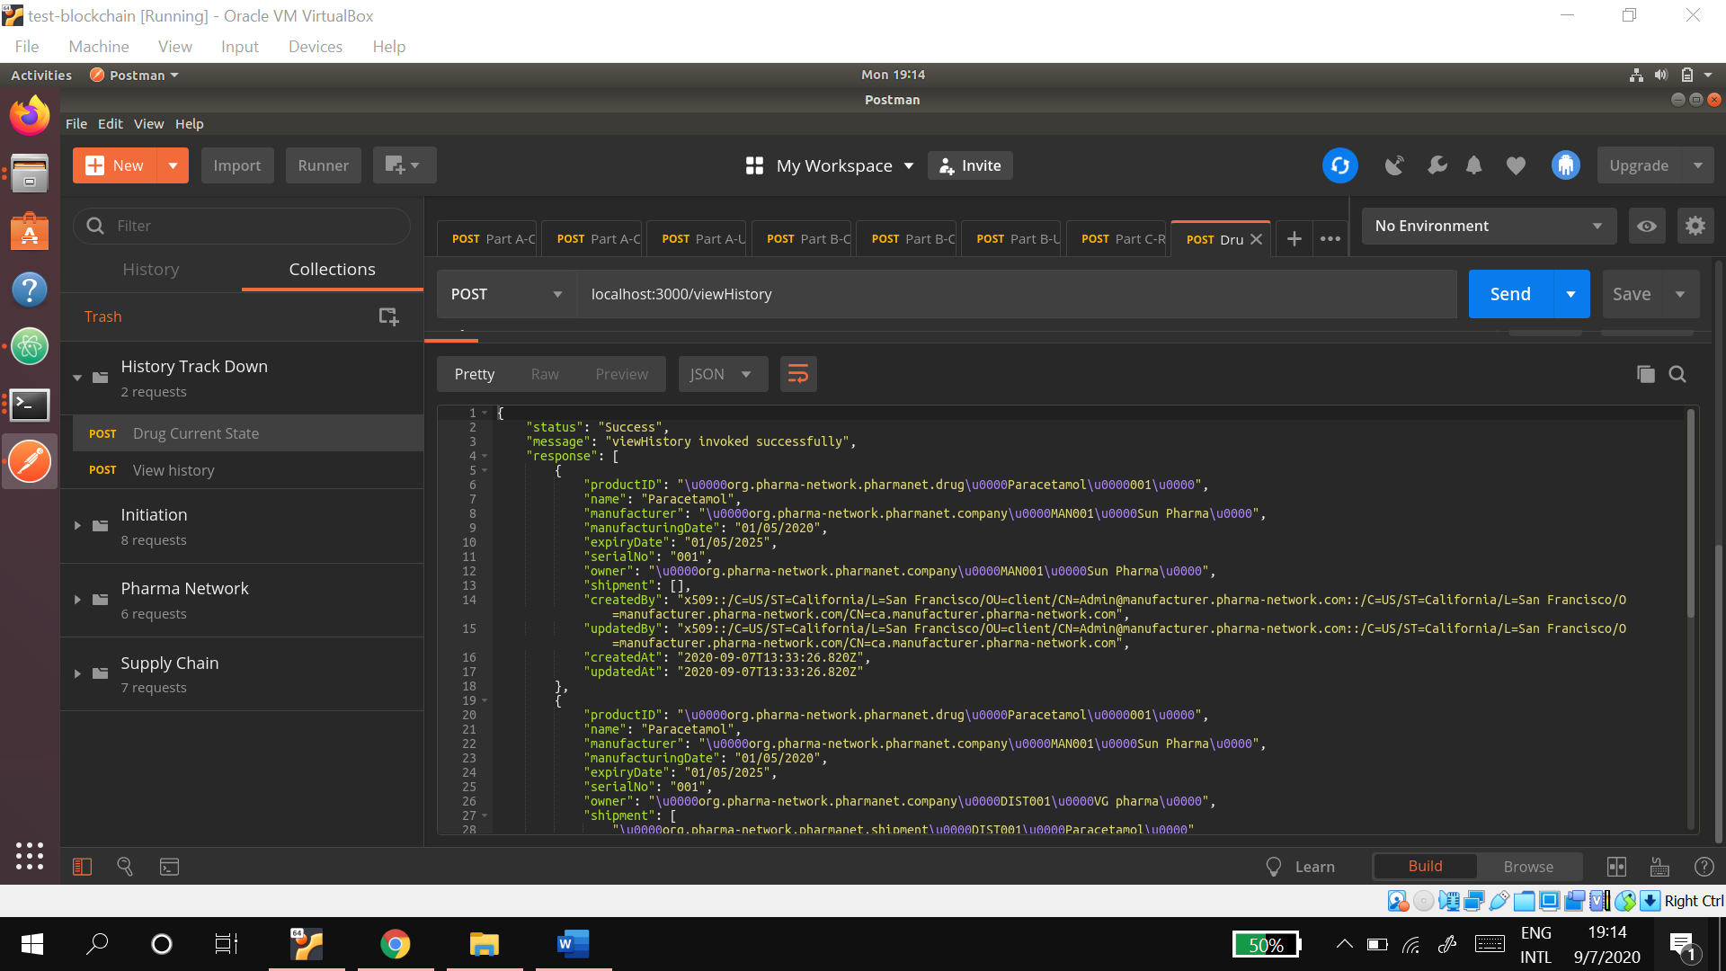
28. The customer 'Akash' wishes to check the current state of the paracetamol that he bought from ‘upgrad’.   
    